**Software Engineering Assignment 8**

**Object State Modelling with State Transition Diagrams**

Notification Authentication Token

SIEM Integration Report

User Account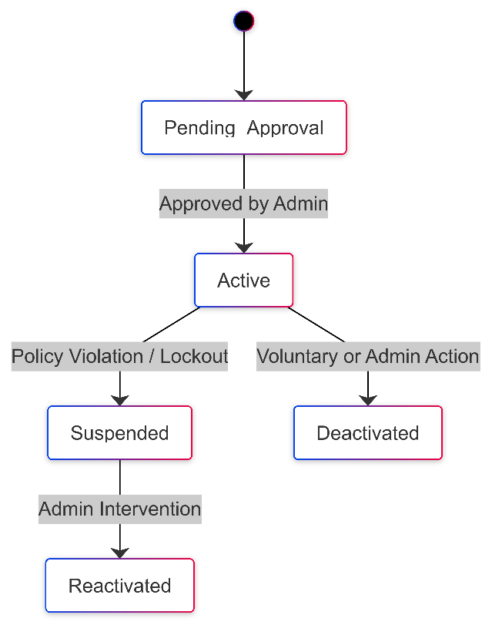

Case Incident

**2. Activity Workflow Modelling with Activity Diagrams**

SIEM Integration

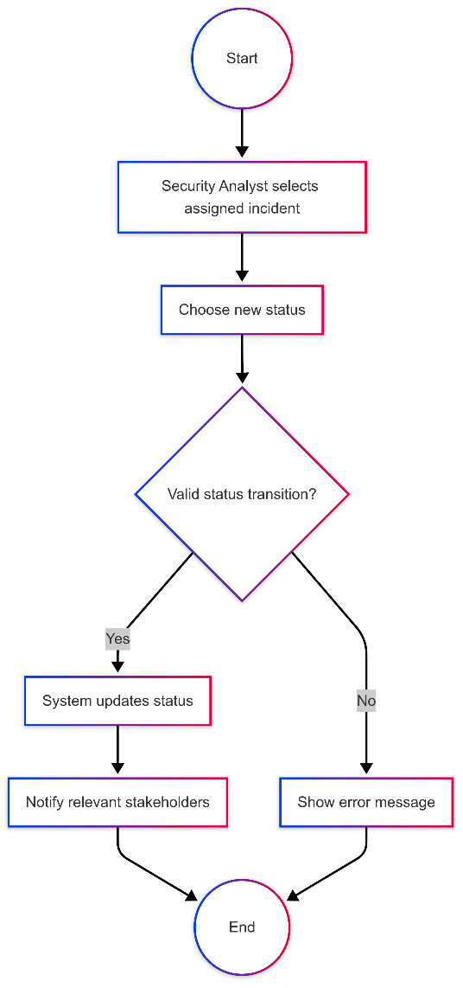

Log Security Incident User Registration